Kathmandu University

School of Engineering

Department of Computer SCIENCE AND ENGINEERING

**Project Report**



**Kathmandu University Android Application**

A **second year project proposal** submitted in partial fulfilment

of the requirements for the degree of

Bachelor of Computer Science

**Group Members:**

**CS 2nd year,**

Swikar Sharma (40)

Anzil Subedi (26)

Bigya Khanal (06)

Rupa Adhikari (16)

**Supervisor:**

Sushil Shrestha

Asst. professor

**5th Feb, 2016**

**Certification**

**Second Year Project Proposal**

**on**

**Kathmandu University Android Application**

**By:**

Swikar Sharma (40)

Anzil Subedi (26)

Bigya Khanal (06)

Rupa Adhikari (16)

**Approved by :**

___________________ ____________________________ __________

(Signature) (Name) (Date)

___________________ ____________________________ __________

(Signature) (Name) (Date)

**ABSTRACT**

*Kathmandu University Android Application is the application that will be designed to help the students who are currently studying and those who wants to join Kathmandu University. The sole propose of this application is to ease accessing Kathmandu University website. This application will provide it's user with the features like notification on notices, Kathmandu University news and exams results and overall information about Kathmandu University. The application will also benefit teachers and Kathmandu University staffs. Currently, there is no any official application of Kathmandu University which makes accessing websites of Kathmandu University unefficient. This application will be easily available to download in Google Playstore. This application will be able to provide campus maps, the entire course catalog, the latest university news, sports schedules etc. The app will not only be helpful to students but also to the teachers and staffs of the University because everyone in the university need to access Kathmandu University website which can be done through our application. The application will be easy to use for all students, Kathmandu University staffs and parents as the interface will be simple and user friendly.*

**TABLE OF CONTENT**

**CONTENTS Page No.**

**Chapter 1: Introduction.....................................................................................................1-2**

1.1 Background**.........................................................................................................**1

1.2 Objectives**............................................................................................................**1

1.3 Problem statement**...............................................................................................**1

1.4 Motivation**............................................................................................................**2

1.5 Scope**....................................................................................................................2**

**Chapter 2:Case study .........................................................................................................2-5**

2.1 Case 1 – LPU Touch**............................................................................................**3

2.2 Case 2 – Howard App**..........................................................................................**4

2.3 Case 3- Rangsit University App**...........................................................................**5

**Chapter 3: System Design....................................................................................................5-6**

3.1 System Overview**..................................................................................................**6

3.2 System Features**....................................................................................................**6

3.3 Algorithm**..............................................................................................................**7

3.4 Flowchart**..............................................................................................................**8

**Chapter 4: Experienced gain and problems encountered................................................9**

**Chapter 5: Conclusion.........................................................................................................9**

**References.............................................................................................................................10**

**Annex 1**: Gantt Chart**............................................................................................................11**

**Annex 2:** Work division**........................................................................................................11**

**1: INTRODUCTION**

**1.1 Background**

Many students of Kathmandu University has to face a lot of trouble while accessing the university’s website.The Kathmandu University website has everything a university website needs but the options and the content layout are not arranged in user friendly manner. Thus, using an application instead of website can be the possible solution for the indicated problem. Hence, we are planing to develop an android application that provide direct access to the university’s website. In this way it will be easier for the students to access various sections of websites and a lot of time can be saved. This application will be able to provide campus maps, the entire course catalog, the latest university news, sports schedules etc. Currently, there is no any official application of Kathmandu University which makes accessing websites of Kathmandu University slow and unefficient. This application will be easily available to download in Google Playstore.

**1.2** **Objectives**

The main objective of our project is :

* To make students have easy access to Kathmandu University website as we can create widgets which is easily accessiable from home screen of an android mobile.
* To provide information about university news and events and connects with students and staffs with easier interface and easy options.
* To keep students update about the new news and events that have been updated in Kathmandu University offical website via notification.
* To help increase the interaction between teachers and students with easy login to E-learning using this application.

**1.3 Problem Statement**

As there are no any official application for Kathmandu University, there is always the problem of unefficient and slow access to Kathmandu University’s website. We hope our app solves the problem.

1

**1.4 Motivation**

Most of the people in the world are with android phone now and are using android application on daily basis, so developing an android application for Kathmandu University website will make visiting website easier.No any proper application is available to access website of Kathmandu University, so we created an application for its efficient access.

**1.5 Scope**

The interface will be way faster than website, the notifications about notices and news will keep the students up to date about the happenings in Kathmandu University. They can even use the website no matter where they will be just by using their phone. The app will not only be helpful to students but also to the teachers and staffs of the University because everyone in the university need to access Kathmandu University website which can be done through our application. From the app, students and staffs can also login their e-learning id which will help in increasing the use of e-learning. As the app is simple and easy to use, it will also be helpful for the parents of the students to access Kathmandu University website even with no web browsing knowledge.

2

**2: Case Study**

**2.1 Case 1: LPU Touch**

It is an android application of Lovely Professional University of India which is the largest university of India. It is an application similar to our project as it provides information about the university efficiently and helps th access its website content. Staff members can remain in touch with the University Management System, 24 x 7, through this app and students can also access their University Management System accounts 24 x 7 through this app.

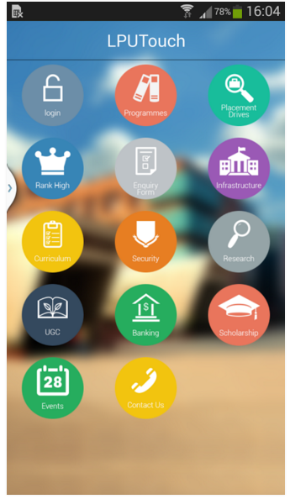 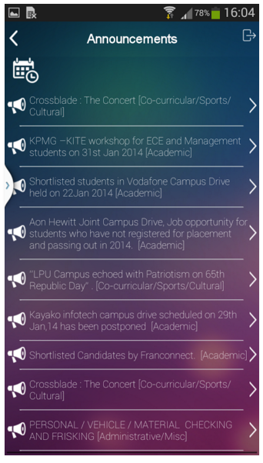

Fig: Homescreen Fig: Announcement

(Source: https://play.google.com/store/apps/details?id=ums.lovely.university)

3

**2.2 Case 2: Howard University Mobile App**

It is also an android application of Howard University of USA. HowardMobile application offers

mobile access to campus maps and real-time bus schedules, the entire course catalog, the latest university news, sports schedules etc. Prospective students and families can navigate the campus and learn about their unique programs and culture through self-guided tours. Whether at home or on campus the interactive student guide will accompany the user as they explore the offerings through the use of the GPS-enabled campus map, student videos and photos.

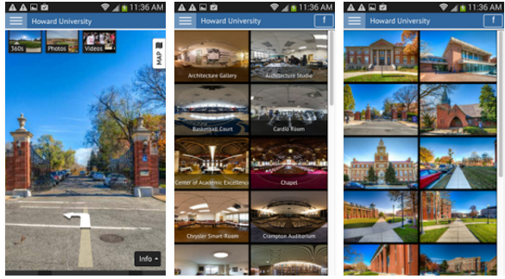 Fig: Howard Virtual Tour Fig: Howard Unversity Special Places

(Source: https://play.google.com/store/apps/details?id=com.yc360.college.howard.howard)

4

**Case 3: Rangsit University App**

It is an application of Rangsit University which helps to access the website of the university. There are many interesting information such as news, scholarships, courses and programs, activities included the 24 hours call center. The app can perfectly handle any choices that user makes in it.

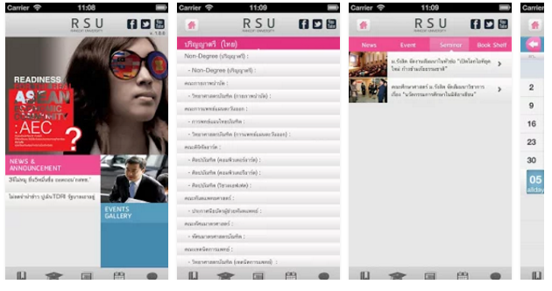

Fig: Front Page of Application. Fig: Selection between different catagories like news, events etc.

(Source: https://play.google.com/store/apps/details?id=com.jorlek.rsu.mobile)

5

**3: System Design**

**3.1 System Overview**

The application is basically an app version of Kathmandu University website. The application has simple interface and the application shows simple options to open the respective contents of the webpage. Each content of the website can be viewed within the application.



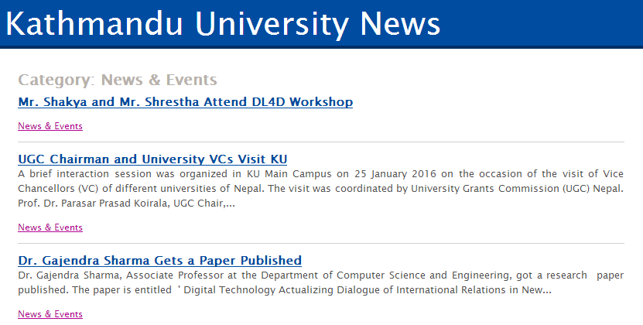

Fig: Splash Screen Of Application Fig: News And Events

Source: <http://ku.edu.np/> Source: http://ku.edu.np/news

:

**3.2 System Features**

The main features of our project is :

* It make students have easy access to Kathmandu University website as we can create widgets which is easily accessiable from home screen of an android mobile.
* It provides information about university news and events and connects with students and staffs with easier interface and easy options menu.
* It helps increase the interaction between teachers and students with easy login to E-learning using this application. 6

**3.3 Algorithm**

1. Start (Open Application).

2. When ‘News and Events’ is choosen, display news page of the website.

3. When ‘Notice and Announcement’ is choosen, display notices page of the website.

4. When ‘Seminar and Talk Program’ is choosen, display seminars page of the website.

5. When ‘e-learning’ is choosen, display login page to e-learning.

6. When ‘Exam section’ is choosen display the exam section of the website.

7. When ‘Academic Program’ is choosen display the academic program section of the website.

8. When ‘Admission’ is choosen display the admission section of the website.

9. When ‘About Kathmandu University’ is choosen display the about page of the website.

10. Stop on exit.

7

**3.4 Flowchart**

Open the application

Open News and Events

Choose News and Events

Open Notice and Annoucement

Choose Notice and Announcement

Open Seminar and Talk Program

Choose Seminar and Talk Program

Open e-learning login page

Choose e-learning

Open Exam Section

Choose Exam Section

Open Academic Program

Choose Academic Program

Open Admission

Choose Admission

Open Admission

Choose About Kathmandu University

**88 8 8**

**4.0: Problems encountered and Experience gain**

* Gradle error occured for first few times while building the project.
* Slow package downloading and accessing made coding tedious.
* Lots of small errors were need to debug.
* The basic and some advance use of Android Studio is now familier to us.
* We also gained some XML knowledge while developing this application.

**5.0: Conclusion**

Hence, our application will help the students and staffs to easily access the website of Kathmandu University. There are no any official application of Kathmandu University which makes accessing websites of Kathmandu University slow and unefficient. The application will be easy to use for all students, Kathmandu University staffs and parents as the interface will be simple and user friendly. Along with this, our project will help us to learn basic web-based android application developement techniques using various programming language and tools like Java, Android Studio etc.

9

**Bibliography**

* Java, How To Program, 10th  edition – Deital, Retrieved on 30th August, 2015
* Lynda tutorials on android development. (source:[www.lynda.com](http://www.lynda.com)), Retrieved on 11th September, 2015
* Head First Java, 2nd edition, Retrieved on 11th September, 2015

10

**Annex 1: Gantt Chart**

The chart below is the proposed Gantt chart showing the time taken to complete different sub tasks of the project:

|  |  |  |  |  |  |  |  |  |  |
| --- | --- | --- | --- | --- | --- | --- | --- | --- | --- |
| **S.N** | **Work Division** | **Dec 7** | **Dec**  **15** | **Dec**  **22** | **Dec**  **30** | **Jan**  **8** | Jan  15 | **Jan**  22 | **Feb**  **1** |
| **1** | **Requirement Gathering** |  |  |  |  |  |  |  |  |
| **2** | **System Design** |  |  |  |  |  |  |  |  |
| **3** | **Coding** |  |  |  |  |  |  |  |  |
| **4** | **Testing** |  |  |  |  |  |  |  |  |
| **5** | **Documentation** |  |  |  |  |  |  |  |  |

|  |  |
| --- | --- |
| **Work to be accomplished** |  |

**Annex 2: Work Division**

The whole task is divided into two sub-tasks assigning team members to each group so as to reduce work load and increase work efficiency. The following table shows the division of team and work.

|  |  |  |  |  |
| --- | --- | --- | --- | --- |
| **Work/names** | **Swikar** | **Anzil** | **Bigya** | **Rupa** |
| **Website Study** |  |  |  |  |
| **Splash Screen Implementation** |  |  |  |  |
| **Main Activity Layout** |  |  |  |  |
| **Menu Layout** |  |  |  |  |
| **Main Java Activity** |  |  |  |  |

-Assigned Work

|  |
| --- |
|  |

11